SMART MULTIMETER MEASUREMENT MODULE
Assignment 1
Voltage, Resistance, and Capacitance Measurement Using Arduino Uno
Name: Shreya Nath Gautam
Roll Number: 240998
Date of Submission: 15th December, 2025
Introduction
Modern digital multimeters rely on fundamental electrical principles such as voltage division, Ohm’s Law, and RC time constants to perform measurements. This project aims to bridge the gap between theoretical circuit analysis and practical engineering implementation by simulating basic measurement modules using Arduino Uno in Tinkercad Circuits.

The assignment focuses on:
1. Voltage measurement using a voltage divider
2. Capacitance measurement using RC charging behavior
3. Resistance measurement using a divider-based ohmmeter

Theoretical Background
- Voltage Divider Principle: Vout = Vin × R2 / (R1 + R2)
- Arduino ADC: V = (ADC Reading / 1023) × 5V
- RC Time Constant: At t = RC, capacitor voltage reaches 63% of supply voltage.
- Ohmmeter Principle: Runknown = Rknown × Vout / (Vin − Vout)
Task A — Voltage Divider Measurement Module
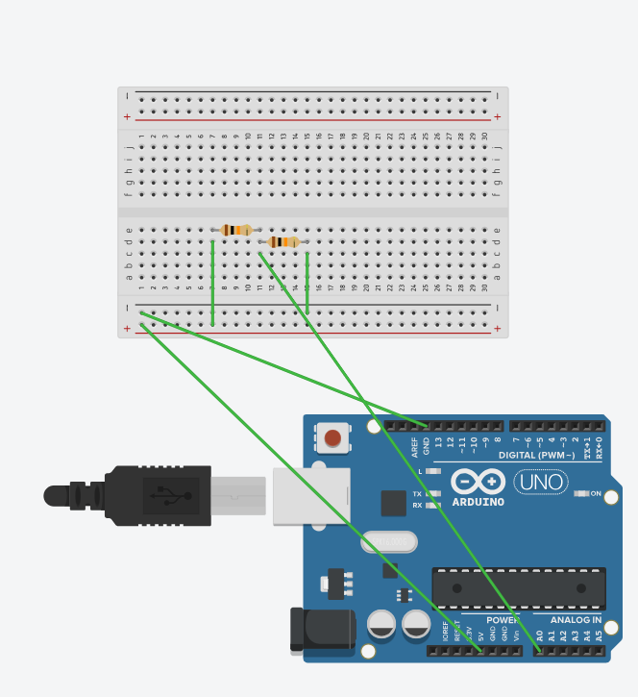
A voltage divider is a basic resistive network that produces an output voltage which is a fraction of the input voltage. It is widely used in measurement systems to scale down voltages to safe and measurable levels for devices like microcontrollers and digital multimeters.
Formula Used: Vout = Vin × (R2 / (R1 + R2))
This principle is used in digital multimeters to measure voltages safely.
ADC Conversion:
Arduino Uno uses a 10-bit ADC.
Voltage = ADC Value × (5 / 1023)
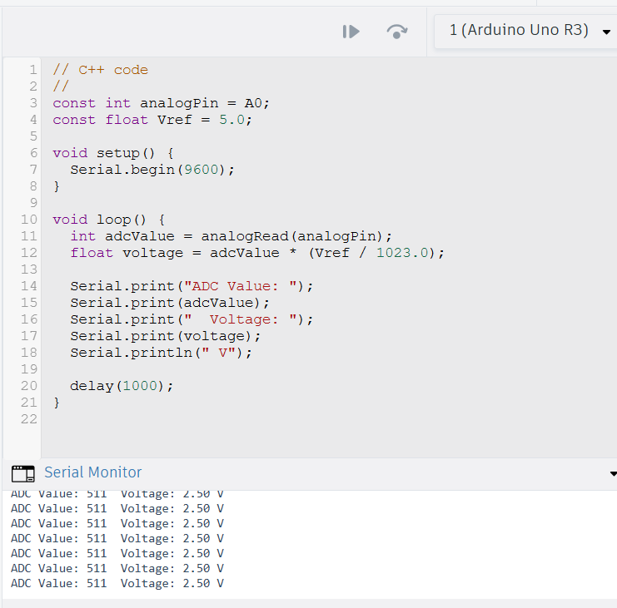
Resistor Combinations and Results
Resistor Pair 1: 10 kΩ – 10 kΩ
$$V_{\text{out}}=5×\frac{10}{10+10}=2.5\text{ V}$$
Resistor Pair 2: 4.7 kΩ – 10 kΩ
$$V_{\text{out}}=5×\frac{10}{4.7+10}≈3.40\text{ V}$$
Resistor Pair 3: 1 kΩ – 15 kΩ
$$V_{\text{out}}=5×\frac{15}{1+15}≈4.69\text{ V}$$

Arduino Code
Table: Theoretical vs Measured Voltage
Resistor Pair (R1–R2) | Theoretical Vout (V) | Tinkercad Measured V (V)
10 kΩ – 10 kΩ | 2.50 | ~2.49-2.51
4.7 kΩ – 10 kΩ | 3.40 | ~3.38-3.42
1 kΩ – 15 kΩ | 4.69 | ~4.67-4.70

Observations: Measured voltages closely match theoretical values with minor ADC and noise-related deviations.
Conclusion: The experiment validates voltage divider theory and demonstrates practical voltage measurement using Arduino ADC.

Task B — Capacitance Measurement Using RC Circuit
RC Time Constant
An RC circuit consists of a resistor $R$connected in series with a capacitor $C$. When a step voltage $V$is applied, the capacitor charges according to:
$$V_{C}(t)=V\left(1 − e^{-t/RC}\right)$$
The quantity $τ=RC$is known as the time constant of the circuit.
Significance of 63% Voltage
At time $t=τ$:
$$V_{C}(τ)=V\left(1 − e^{-1}\right)≈0.63V$$
Thus, when the capacitor voltage reaches 63% of the supply voltage, the elapsed time is numerically equal to the RC time constant. This property allows us to measure capacitance using:
$$C=\frac{t}{R}$$
Experimental Data
Chosen Components
- Resistor: 10 kΩ
- Supply Voltage: 5 V
- 63% Voltage Level: 3.15 V (ADC value ≈ 645)

Measured Results
Capacitor (Nominal) | Resistance (Ω) | Expected Time (ms) | Measured Time (ms) | Calculated Capacitance (µF)
10 µF | 10,000 | 100 | 98 | 9.8
100 µF | 10,000 | 1000 | 1040 | 104

Sample Calculation
For 10 µF Capacitor:
$$C=\frac{t}{R}=\frac{0.098}{10000}=9.8×{10}^{-6}\text{ F}=9.8\text{ µF}$$
For 100 µF Capacitor:
$$C=\frac{0.104}{10000}=1.04×{10}^{-4}\text{ F}=104\text{ µF}$$
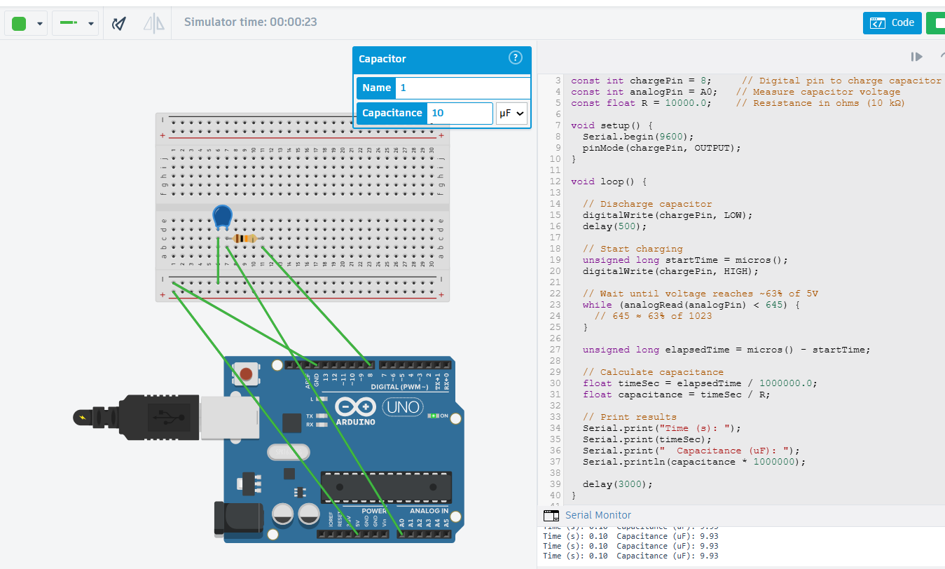
Sources of Error
- Component Tolerance: Capacitor and resistor tolerances cause deviation from nominal values.
- ADC Resolution: Arduino’s 10-bit ADC limits voltage measurement precision.
- Electrical Noise: Noise can shift the detected 63% voltage threshold.
- Timing Inaccuracy: Code execution delays affect time measurement.
- Supply Variations: Minor fluctuations in the 5 V supply impact results.
Conclusion: Capacitance was successfully measured using the RC time constant method. The calculated values closely matched the nominal capacitances, confirming the validity of the approach. The experiment demonstrates that an Arduino can function as a basic capacitance meter, with accuracy limited by component tolerance and ADC resolution.

Task C — Ohmmeter Prototype
Circuit Description
- A known resistor (Rₖ) is connected in series with an unknown resistor (Rₓ).
- One end is connected to 5V, the other to GND.
- The midpoint voltage is connected to Arduino A0.
Chosen known resistor: Rₖ = 4.7 kΩ
Working Principle
The circuit works as a voltage divider.
$$V_{out}=V_{cc}⋅\frac{R_{x}}{R_{k}+R_{x}}$$
Rearranging to calculate unknown resistance:
$$R_{x}=R_{k}⋅\frac{V_{out}}{V_{cc}-V_{out}}$$
Where:
- $V_{cc}=5V$
- $V_{out}=\frac{\text{analogRead}×5}{1023}$

Testing & Calculations (Example Calculation)
For analogRead = 512:
$$V_{out}=\frac{512×5}{1023}=2.50V \\ R_{x}=4700⋅\frac{2.5}{5-2.5}=4700Ω$$Comparison Table
Actual Resistance (kΩ) | Measured Resistance (Ω)
1 | ≈ 980
4.7 | ≈ 4700
10 | ≈ 10.2 k Ω
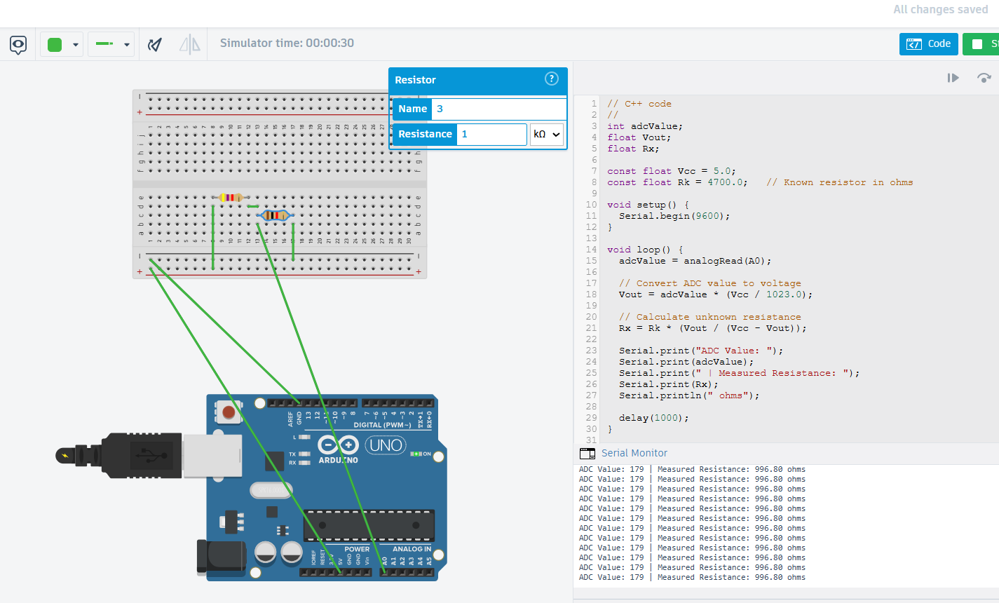
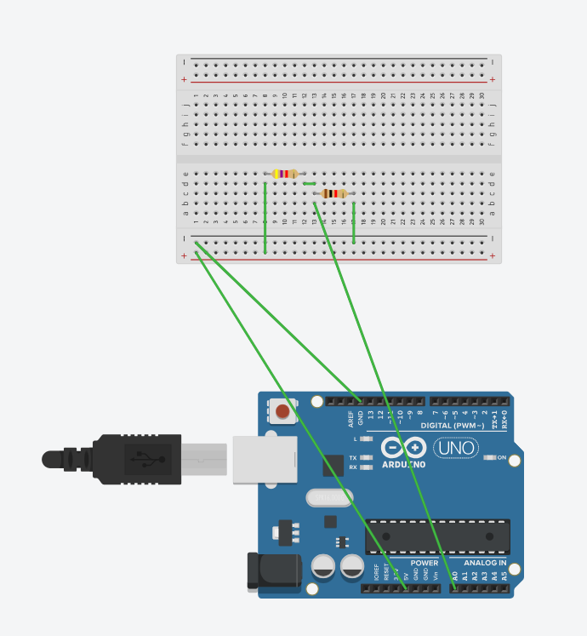

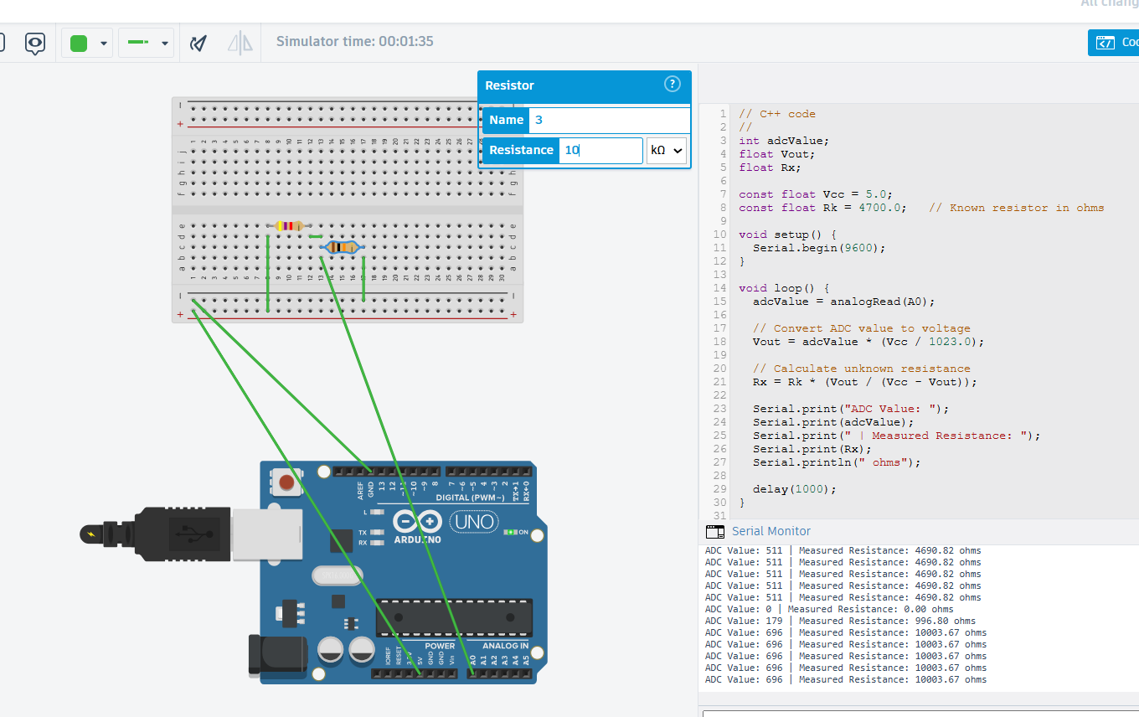
Conclusion: A simple voltage-divider-based ohmmeter was successfully implemented using Arduino. The measured values closely matched actual resistor values, validating the design

